Water when you are thirsty

Drink it from a goblet,

Drink it from a cup,

Drink it when you are sitting down,

Water when you are thirsty

Drink it from a goblet, 

Drink it from a cap.

Drink it when you are sitting down, C:\Users\Наталья\AppData\Local\Microsoft\Windows\Temporary Internet Files\Content.IE5\14BCBTA3\MC900330879[1].wmf

Or when you are standing up.

Drink it when you are very big, 

Or very,very small.

But drink it when you are thirsty,

And then it is best of all! 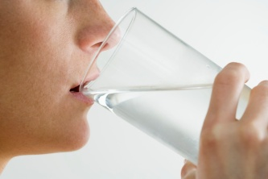

Перевод.

Пей в бокале,

Пей в стакане. 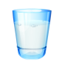

Пей когда сидишь,

Или когда стоишь. 

Даже если великан,

Или просто мальчуган. 

Или просто пей её,

Вода это лучше всего! 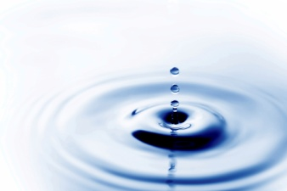

Полуяхтова А. 5б